**[ Laboratory No. 2.4:** **Count]**

**Objectives:**

1. To know the loop construct in Python Programming
2. To create a program that take advantage of the loop mechanisms

**Materials:**

1. PC or Laptop
2. Python Package Development Kit
3. Pycharm or any IDE

**Background:**

***…Continuation***

**@Split by whitespace.** By default, split() takes whitespace as the delimiter.

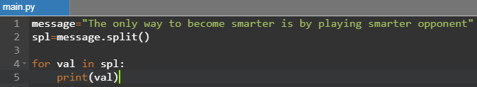

***Output:***

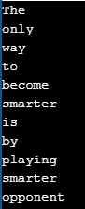

**@Split + maxsplit.** An example by first 5 whitespaces only.

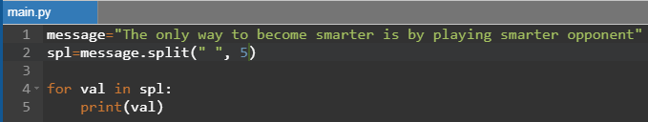

***Output:***

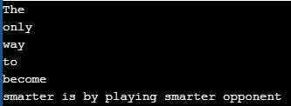

**@Split by #**

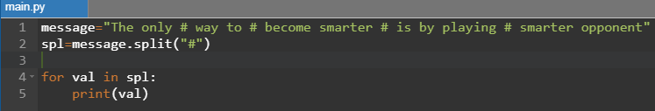

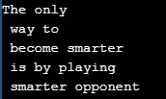

**More on String functions**

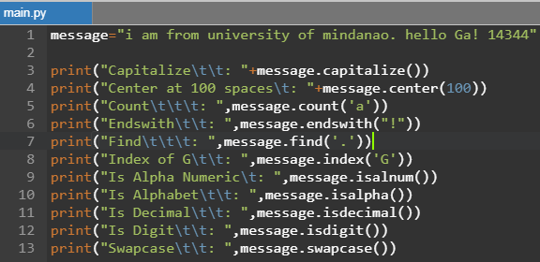

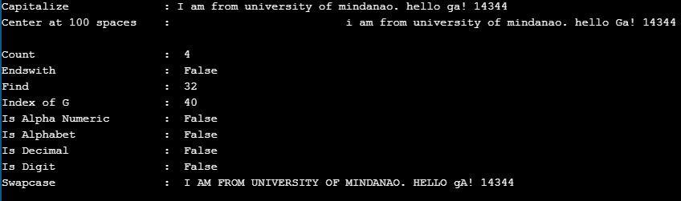

**Instructions:**

1. Create class **Count*[Surname]***
2. **Problem Scenario**

Create a program that accepts string value in sentence with mix of numbers and special characters. Afterwards, the program will then count how many **special characters, total alphabets, consonants and vowels, total number of digits, odd and even** digits.

1. **Input**

Input consist of a string input, a statement or sentence with mix of alphanumeric, special characters.

1. **Constraints**

Input must NOT be null or empty. Whitespaces such as space and tabs are included as special characters.

1. **Output**

Your program should count/output the following:

**special characters**

**total alphabets**

**consonants**

**vowels**

**total number of digits**

**odd**

**even**

1. **Source Codes**

|  |
| --- |
|  |

1. **Sample Input/Output**

**NOTE: Provide a screenshot and describe your observation for each action you performed based on the item below:**

* **Input valid value for string**
* **Empty value for string**
* **Try to implement split() in your program using any character.**

1. **Submit your file with filename convention: Count*[Surname]***

**Rules:**

1. Each laboratory activity has time limit of 1:30 minutes and is due on the day depending on the level of difficulty or constraints.
2. Each activity will only last every after 3 days and has deduction of 10 points every day from the day it was given.